Lab: Objects and Classes
Problems for exercises and homework for the "Programming Fundamentals" course @ SoftUni
You can check your solutions in Judge.

Using the Built-in Java Classes

Randomize Words
You are given a list of words in one line. Randomize their order and print each word on a separate line.

Examples
Input | Output | Comments
Welcome to SoftUni and have fun learning programming | learning  Welcome  SoftUni  and  fun  programming  have  to | The order of the words in the output will be different after each program execution.
Java is the best programming language | the  programming  best  language  is  Java

Hints
- Split the input string (by space) and create an array of words.
- Create a random number generator - an object rnd of type Random.
- In a for-loop exchange, each number at positions 0, 1, …, words.Length-1 by a number at random. position. To generate a random number in range use rnd.nextInt(words.length).
- Print each word in the array on a new line.

Sum Big Numbers
You will receive two numbers (0 to 10⁵⁰), and print their sum.

Examples
Input | Output
923847238931983192462832102  934572893617836459843471846187346 | 934573817465075391826664309019448
4  100 | 104

Hints
Use the class BigInteger
Import the namespace "java.math.BigInteger":
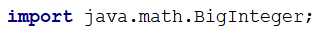
Use the type BigInteger to read the numbers and calculate their sum:
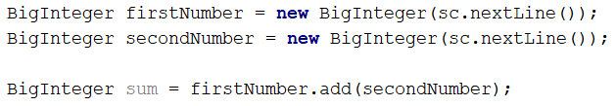

Big Factorial
You will receive N - the number in the range [0 - 1000]. Calculate the Factorial of N and print the result.

Examples
Input | Output
5 | 120
50 | 30414093201713378043612608166064768844377641568960512000000000000

Defining Simple Classes

Songs
Define a class Song, which holds the following information about songs: Type List, Name, and Time.
On the first line, you will receive the number of songs - N.
On the next N-lines, you will be receiving data in the following format: "{typeList}_{name}_{time}".
On the last line, you will receive "Type List" / "all". Print only the names of the songs which are from that Type List / All songs.

Examples
Input | Output
3  favourite_DownTown_3:14  favourite_Kiss_4:16  favourite_Smooth Criminal_4:01  favourite | DownTown  Kiss  Smooth Criminal
4  favourite_DownTown_3:14  listenLater_Andalouse_3:24  favourite_In To The Night_3:58  favourite_Live It Up_3:48  listenLater | Andalouse
2  like_Replay_3:15  ban_Photoshop_3:48  all | Replay  Photoshop

Solution
Define class Song with fields: Type List, Name, and Time:
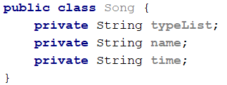
Define getters and setters: use keys ALT + INS and generate Getter and Setter:
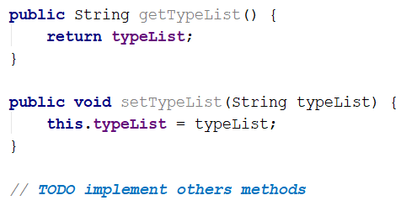
Read the input lines, make the collection, and store the data:
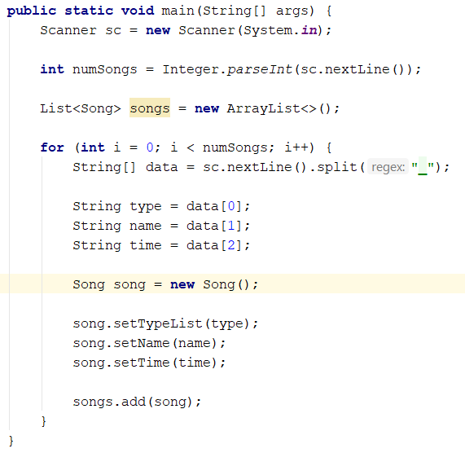
Finally, read your last line – Type List and print the result:
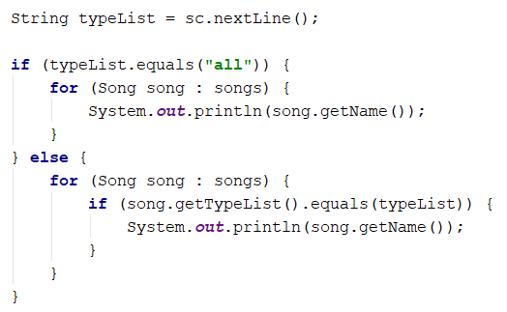
You can use Stream API to filter the collection:
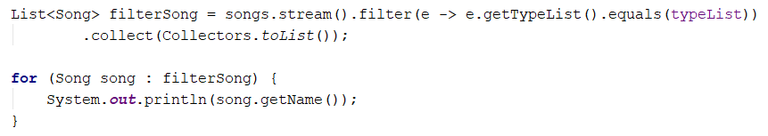

Students
Define a class Student, which holds the following information about students: first name, last name, age, and hometown.
Read the list of students until you receive the "end" command. After that, you will receive a city name. Print only students which are from the given city, in the following format: "{firstName} {lastName} is {age} years old".

Examples
Input | Output
John Smith 15 Sofia  Peter Ivanov 14 Plovdiv  Linda Bridge 16 Sofia  Simon Stone 12 Varna  end  Sofia | John Smith is 15 years old  Linda Bridge is 16 years old
Anthony Taylor 15 Chicago  David Anderson 16 Washington  Jack Lewis 14 Chicago  David Lee 14 Chicago  end  Chicago | Anthony Taylor is 15 years old  Jack Lewis is 14 years old  David Lee is 14 years old

Solution
Define a class student with the following properties: firstName, lastName, age, and city:
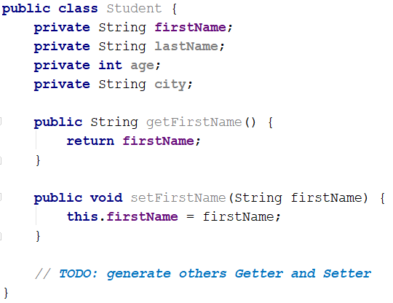
Generate constructor in class Student: ALT + INSERT
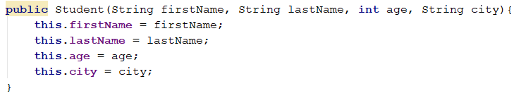
Read a list of students.
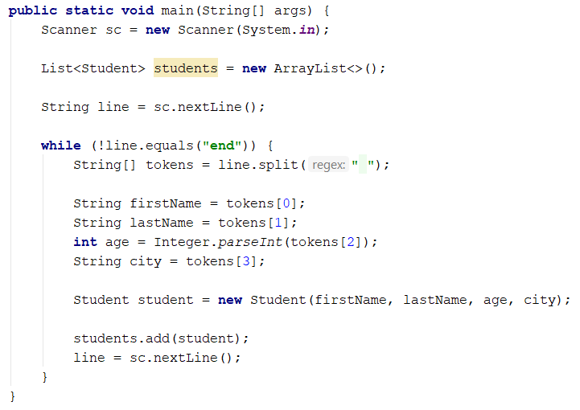
Read a city name and print only the students who are from the given city.
You can filter the students with the stream.
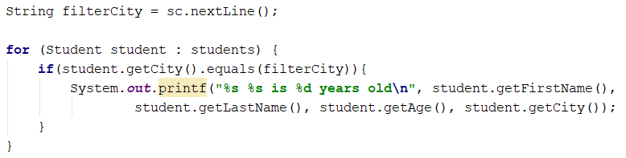

Students 2.0
Use the class from the previous problem. If you receive a student who already exists (first name and last name should be unique), overwrite the information.

Hints
Check if the given student already exists:
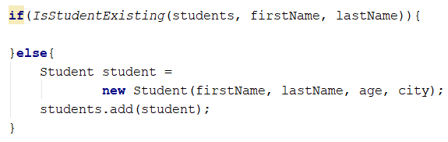
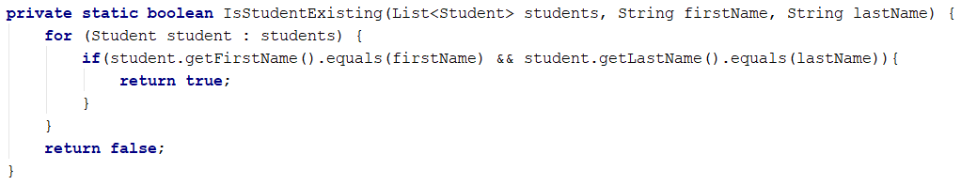
Overwrite the student information.
First, we have to find the existing student:
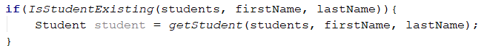
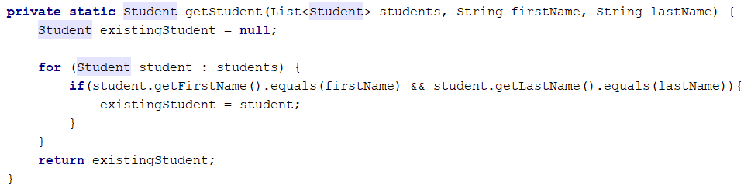
Finally, we have to overwrite the information:
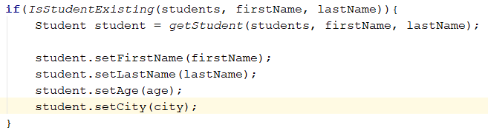
We can use Stream API as well:
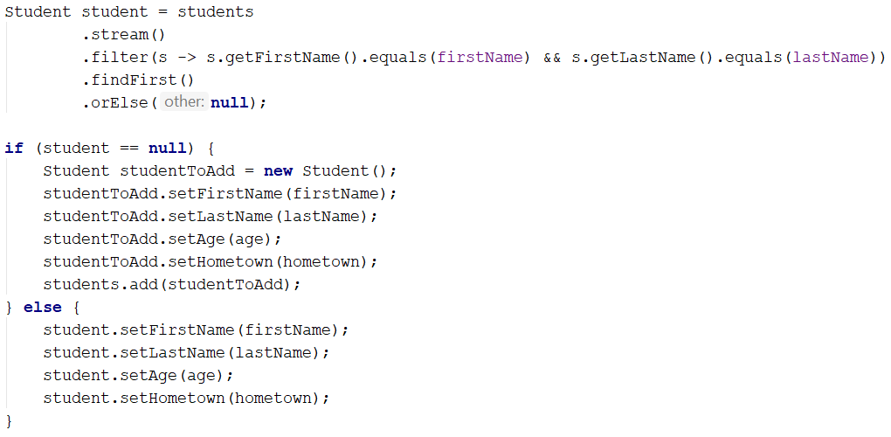
findFirst returns the first occurrence or null.

Examples
Input | Output
John Smith 15 Sofia  John Smith 16 Sofia  Linda Bridge 17 Sofia  Simon Stone 12 Varna  end  Sofia | John Smith is 16 years old  Linda Bridge is 17 years old
J S 3 S  Peter Ivanov 14 P  P J 104 S  J P 61 S  Simon Stone 12 Varna  Simon Sone 12 Varna  end  Varna | Simon Stone is 12 years old  Simon Sone is 12 years old

